

**YEAR: 10**

**2018**

**SUBJECT: Science**

**TEST: Forensic science**

**TIME: 50 minutes**

**QUESTIONS: 15 Multiple Choice (15 marks)**

**6 Short Answer (22 marks)**

**3 Case Study (8 marks)**

**TOTAL MARKS: 45 marks**

**DO NOT WRITE ON OR MARK THIS PAPER**

**SECTION ONE—MULTIPLE CHOICE (15 marks)**

This section has **15** questions. Answer **all** questions on the separate Multiple-choice Answer Sheet provided.

1. The term “forensic science” means

1. The science of criminology
2. The science to commit a crime
3. The science used in law courts
4. The scientists that are criminals

2. To be a good eyewitness, a person should be:

1. Tired and angry
2. Alert and observant
3. Alert and angry
4. Tired and observant

3. Small items of evidence left at crime scenes are:

1. Touch traces
2. Contact touches
3. Clothes contacts
4. Contact traces

4. Major crimes that come to court are mainly placed in front of a:

1. judge
2. jury
3. magistrate
4. lawyer

5. Ballistics is the study of:

1. ball bearings
2. bailiffs
3. guns
4. guns and bullets.

6. The Lockard Exchange Principle says that

1. every contact leaves a trace
2. evidence can always be found
3. evidence found at crime scenes always lead to prosecution
4. criminals always makes mistakes

7. The microscope used by forensic laboratories is the _____________ microscope.

1. electron
2. compound
3. comparison
4. stereoscopic

8. Which of the fibres below are natural?

1. linen
2. rayon
3. nylon
4. polyester

9. The instrument used to study fibres in detail is:

1. Spectroscope
2. Telescope
3. Microscope
4. Stethoscope

10. The most common type of fingerprint pattern is:

1. arch
2. loop
3. whorl
4. delta

11. Under a microscope, a hair sample with a smooth and regular surface, it is likely to be;

1. human hair
2. horse hair
3. synthetic hair
4. wool

12. Blood is a complex mixture of four main components. Red blood cells, white blood cells, platelets and _________________?

1. syrup
2. oxygen
3. water
4. plasma

13. Apart from fingerprints what other evidence could help identify a body?

1. DNA
2. clothing
3. jewellery
4. hair

14. The most common blood type of people in the U.K., U.S.A. and Australia is?

1. A
2. B
3. O
4. AB

15. Name the substance that is not produced by sweat glands:

1. water
2. amino acids
3. salts
4. oil



**SEMESTER TWO 2018**

**Forensic science Test:**

**ANSWER BOOKLET**

**NAME:**

**FORM:** **DATE:**

Multiple Choice Short Answer Case Study Total

**/22**

**/8**

**/45**

**/15**

**SECTION ONE:** Multiple choice answers

Cross (X) through the correct answer.

|  |  |  |  |  |
| --- | --- | --- | --- | --- |
| **1** | a | b | c | d |
| **2** | a | b | c | d |
| **3** | a | b | c | d |
| **4** | a | b | c | d |
| **5** | a | b | c | d |
| **6** | a | b | c | d |
| **7** | a | b | c | d |
| **8** | a | b | c | d |
| **9** | a | b | c | d |
| **10** | a | b | c | d |
| **11** | a | b | c | d |
| **12** | a | b | c | d |
| **13** | a | b | c | d |
| **14** | a | b | c | d |
| **15** | a | b | c | d |

**SECTION TWO: Short Answer (22 marks)**

Answer the questions in the spaces provided.

1. Look at the prints below. **Circle** the print which best matches the one found at the crime scene. (1 mark)

\\e4128s01sv001.green.schools.internal\temp$\staff\201809181514-1.tif

2a) Which of the three blood droplets shown would have be created by a wound to the upper body? Circle you choice and explain. (2 marks)

_______________________________________________________________________________

_______________________________________________________________________________

b) What does the blood droplet shown below tell you? Explain your answer. (2 marks)

_______________________________________________________________________________

_______________________________________________________________________________

c) Look at the two blood drop patterns below. Which one would be match a person walking at a fast speed? Explain your answer. (2 marks)

_______________________________________________________________________________

_______________________________________________________________________________

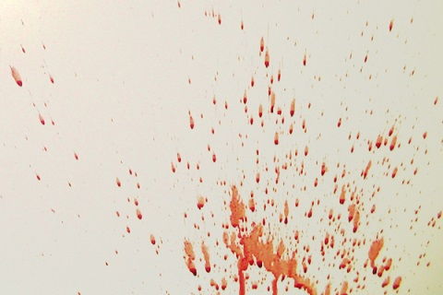

d) What can we conclude from this pattern above? (2 marks)

_______________________________________________________________________________

_______________________________________________________________________________

3. Look at the **(fake!)** crime scene below. Circle the three differences in the second picture.

(3 marks)

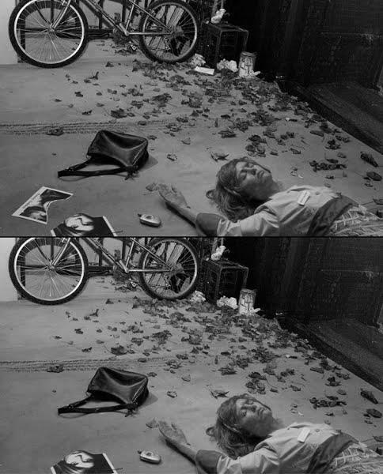



4. Describe 4 things must be done at a crime scene.

(2 marks)

_______________________________________________________________________________

_______________________________________________________________________________

_______________________________________________________________________________

_______________________________________________________________________________

_______________________________________________________________________________

**5. List** the two types of fibres. Describe **two differences** and give **two examples** of each type.

Types of fibres (2 marks)

_______________________________________________________________________________

Differences: (2 marks)

_______________________________________________________________________________

_______________________________________________________________________________

_______________________________________________________________________________

_______________________________________________________________________________

Examples: (2 marks)  
  
_______________________________________________________________________________

_______________________________________________________________________________

**6.** Label the following diagram. (2 marks)

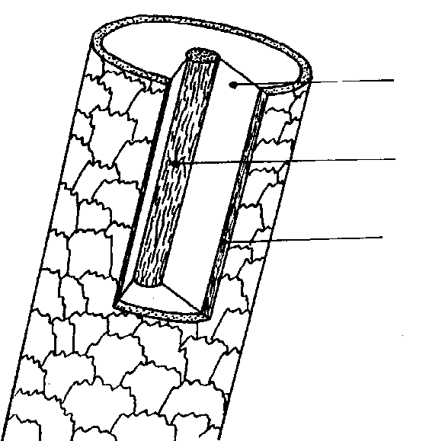

**Section THREE: Case Study**

Read the following article and answer the questions below:

\\e4128s01sv001.green.schools.internal\temp$\staff\201809181514.tif

7. List the trace evidence found with the boy’s body. (1 mark)

_______________________________________________________________________________

_______________________________________________________________________________

8. Did all the evidence prove the suspect’s guilt? Explain your answer. (2 marks)

_______________________________________________________________________________

_______________________________________________________________________________

_______________________________________________________________________________

_______________________________________________________________________________

9. What evidence found in this 1960 crime could be better analysed today? Describe how this evidence would have been processed and what it could have shown us. (5 marks)

_______________________________________________________________________________

_______________________________________________________________________________

_______________________________________________________________________________

_______________________________________________________________________________

_______________________________________________________________________________

_______________________________________________________________________________

_______________________________________________________________________________

_______________________________________________________________________________

**END OF TEST**

Please check your work!